Summer Quarter 2014 Course Announcement
Center For Multicultural Education

EDC&I 505A (Seattle) B EDUC 520 A(Bothell)
Race, Class, Gender, and Social Inequality
M-F 1:10-4:30PM, July 21st – August 1st
Dempsey Hall 002
schedule line #11184 (Seattle), # 10315 (Bothell), 3 credits, CR/NC
e-mail: edcodes@uw.edu for add code/registration questions
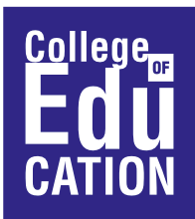

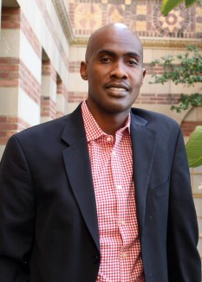

Instructor: Tyrone Howard
Faculty Director, Center X and Director, Black Male Institute
Graduate School of Education and Information Studies
University of California at Los Angeles

Course Description
Education has been viewed as one of the most viable and effective routes to upward mobility in the United States. An educated citizenry has also been seen as a key element in the maintenance of democracy. However, access to public education has not always been available to all segments of our society. This course will provide students with a basis for understanding the educational experiences of different groups in the United States. We will focus extensively on the following groups: African Americans, Asian Americans and Pacific Islanders, Chicanas/os/Latinas/os, Native Americans, women, and low-income White Americans. The experience of these groups in U.S. public schools and their efforts to utilize education to improve their socio-economic status will serve as the focus for the course.

Center for Multicultural Education  University of Washington  110 Miller Hall, Box 353600  Seattle, WA 98195-3600  Phone: (206) 543-3386 Fax: (206) 543-1237  Email: centerme@u.washington.edu  Website: http://education.uw.edu/cme | 